Software Requirements Specification

Revision History
Rev | Date | Revision History
00 | 2025.02.28 | First Issued.

Contents
1. Purpose 4
2. Specification 4
2.1 Software Specification 4
2.2 Hardware Specification 4
2.3 System Input / output 5
2.4 Inter-System Interface 5
2.5 Security 6
2.6 User Interface Requirements 6
2.7 Data Define and Database Requirements 6
3. Software requirement specification 7

- Purpose
This product utilizes Optical Coherence Tomography (OCT) imaging technology, based on a catheter inserted into the cardiovascular system, to medically assess the severity of cardiovascular diseases. The system projects a near-infrared beam with a wavelength of 1300 nm onto the vascular inner wall from the inserted catheter, detects the reflected light, and converts it into digital signals. This allows for real-time image playback, storage, and display processes. Additionally, the product can predict Fractional Flow Reserve (FFR), a functional testing method for cardiovascular diseases, using machine learning techniques that analyze cardiovascular OCT image parameters.
- Specification
  - Software Specification
Software name | FasterDx
Software version | 1.00.00
Operating system | Windows 10 IoT Ent.
Programmable language | C++, C#
Safety Level | Class B
  - Hardware Specification
Main Board | MSI MAG Z690 TOMAHAWK WIFI
CPU | 12th Generation Intel® Core™ i7 Processors
GPU | ASUS Dual GeForce RTX™ 3060 Ti
Memory | SAMSUNG ELECTRONICS CO., LTD. DDR5-4800 (32GB) x 2
Storage | SAMSUNG ELECTRONICS CO., LTD. 980 PRO M.2 NVMe (2TB)
  - System Input / output
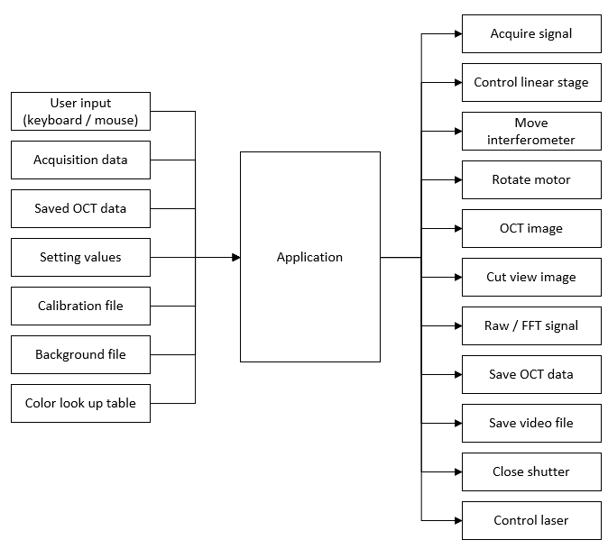
  - Inter-System Interface
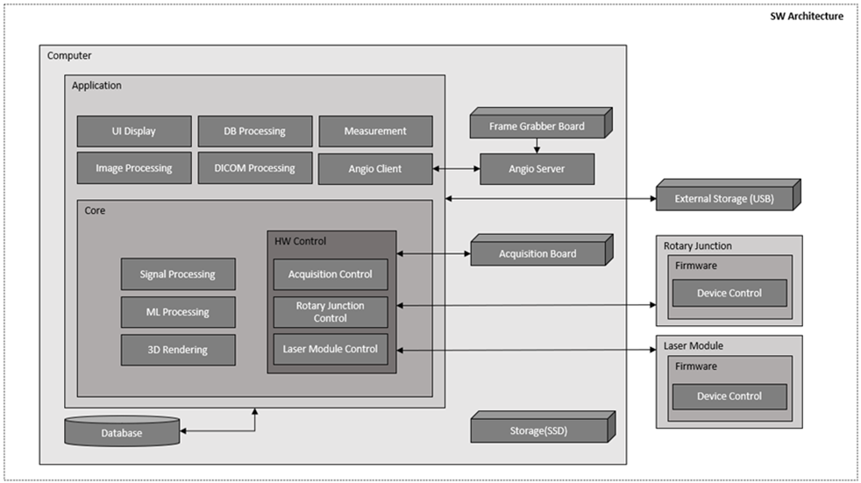
  - Security
1. When selecting "Anonymous" during the export of patient information, the patient details are concealed.
2. The device operator is granted the authority to create accounts within the software system, and the operator has access to patient information and can modify relevant data for medical purposes.
  - User Interface Requirements
1. Users interact with the software using a mouse, keyboard, or the touchscreen of the monitor.
2. The software functions are based on manual user operations. However, it supports and allows modifications to automated operations that can complement human reaction times.
3. Operation of the device is restricted to trained operators who must exercise caution when communicating with the rotary junction device to perform the pull-back function.
  - Data Define and Database Requirements
1. Patient ID: Char (9)
2. Patient Name: Char (20: First, 20: Last)
3. Birth: date (YYYY-MM-DD)
4. Create date: timestamp without time zone (YYYY-MM-DD HH:MM:SS)
5. Update date: timestamp without time zone (YYYY-MM-DD HH:MM:SS)
6. Patient Case ID: Char (24)
7. Lumen Contour: text (Json)
8. Lumen Side branch: text (Json)
9. Lumen Stent: text (Json)
10. Lumen Guidewire: text (Json)
If it is needed to handle additional requirements or stability of system, more fields could be added in Database later.

- Software requirement specification
The Software Requirements Specification (SRS) determines the intended design requirements and allows the tester to verify that it meets the requirements of the equipment. SRS describes all inputs, outputs, and all functions performed by the software.
The details are listed in Attachment 1.

